# Principal Component Analysis (PCA) – Easy Notes

## 1. Introduction

In Machine Learning, we often have **data with many features (columns)**.

Example:

| No of Rooms | No of Washrooms | Size | Price |
| ----------- | --------------- | ---- | ----- |

Sometimes:

* Too many features
* Some features are not useful
* Computation becomes slow
* Hard to visualize

So we use **Dimensionality Reduction**

There are two methods:

* Feature Selection
* Feature Extraction

---

# 2. Feature Selection

Feature selection means:

👉 **Selecting existing columns**
👉 **Deleting unwanted columns**

Example:

| Rooms | Grocery Shops | Price |

Suppose you want to remove one column.

Question:

How to decide which column to remove?

### Case 1: Using Domain Knowledge

You may think:

Rooms affect price more than grocery shops

So delete grocery shops column

This is Feature Selection

---

# Problem:

What if you **do not have domain knowledge?**

How to decide?

Answer: Use **Variance**

---

# 3. Variance Concept (Important)

Variance tells:

👉 **How much data is spread**

Formula:

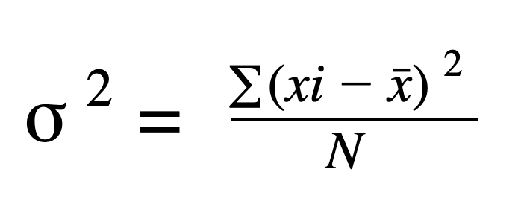
Where:

* xi = data point
* x̄ = mean

---

# Why variance is important?

Example:

Graph between:

Rooms vs Price
Grocery Shops vs Price

Observation:

* Grocery shops → less spread → less variance
* Rooms → more spread → more variance

Conclusion:

👉 Feature with **higher variance is more important**

So keep Rooms

Delete Grocery Shops

This is Feature Selection using variance

---

# Problem Case 2

Example:

Rooms and Washrooms

Both have **same variance**

Graph spread is same

Now question:

Which column to select?

You cannot decide

Now Feature Selection fails

---

# 4. Feature Extraction

When you cannot delete any feature,

You create **new feature**

This is called Feature Extraction

Example:

Old features:

Rooms
Washrooms

New feature:

Combination of both

This new feature contains information of both

---

# 5. Real Life Example – Photographer Example

You live in 3D world

But camera takes 2D image

Means:

3D → converted into 2D

Information preserved

Same concept PCA uses

Higher dimension → Lower dimension

---

# 6. What PCA Does

PCA converts:

Old features → New features

These new features are called:

# Principal Components

Important points:

* Number of Principal Components ≤ Number of original features

Example:

If features = 3

PC ≤ 3

---

# 7. Geometric Intuition (Very Important)

Suppose you have 2 features:

Rooms
Washrooms

Plot graph

Now PCA will:

Rotate axis

Create new axis

PC1
PC2

PC1 → maximum variance

PC2 → second maximum variance

We select PC1

Because it contains more information

Convert:

2D → 1D

---

# 8. Why PCA uses Variance

Because:

More variance → more information

Less variance → less information

Example:

Points:

-5, 0, +5

Mean = 0

Variance:

[
(-5)^2 + 0^2 + 5^2 / 3
]

Variance is high → spread is high

---

# 9. Why square is used in variance?

Because square is:

Differentiable

Differentiation is needed for optimization

Mean absolute deviation is not easy to differentiate

So square is used

---

# 10. Benefits of PCA

## Benefit 1: Reduce Dimension

Example:

100 columns → 10 columns

Benefit:

* Faster training
* Less computation
* Less memory

---

## Benefit 2: Visualization

Example:

100D data → 2D

Can plot graph

Can understand data

---

## Benefit 3: Remove Noise

PCA keeps important information

Removes less important information

